answers
1.
Here is a data set:
286 | 249 | 246 | 348
228 | 237 | 336 | 266
233 | 363 | 287 | 244
272 | 285 | 198 | 339
291 | 377 | 293 | 281
357 | 333 | 182 | 234
237 | 283 | 229 | 275
286
Construct a grouped frequency distribution table (GFDT) for this data set. You want 10 classes with a "nice" class width. Your classes should be labeled using interval notation. Each class contains its lower class limit, and the lower class limits should all be multiples of the class width. In that the data appears to be discrete, use a closed-interval to label each class.
Data range | Frequency
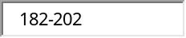 | 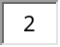
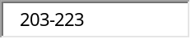 | 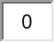
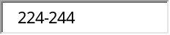 | 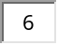
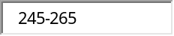
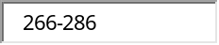 | 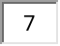
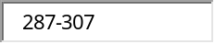 | 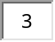
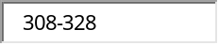
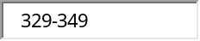 | 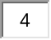
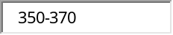
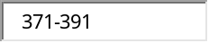 | 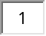

2.
Here is a data set:
479 | 718 | 665 | 434
523 | 552 | 631 | 367
470 | 488 | 462 | 647
617 | 518 | 739 | 767
691 | 682 | 841 | 558
730 | 645 | 548 | 518
704 | 510 | 559 | 402
Construct a grouped frequency distribution table (GFDT) for this data set. You want 10 classes with a "nice" class width. Your classes should be labeled using interval notation. Each class contains its lower class limit, and the lower class limits should all be multiples of the class width. In that the data appears to be discrete, use a closed-interval to label each class.
Data range | Frequency
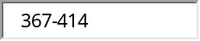
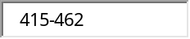
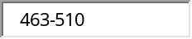
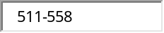
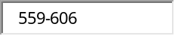
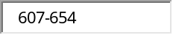
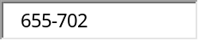
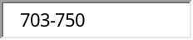
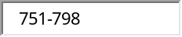
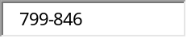

3.
Here is a data set:

468 | 468 | 492 | 487
514 | 480 | 459 | 495
525 | 545 | 522 | 476
479 | 478 | 539 | 512
489 | 462 | 522 | 496
504 | 492 | 459 | 516
497 | 502 | 545 | 500
Construct a grouped frequency distribution table (GFDT) for this data set. You want 10 classes with a "nice" class width. Your classes should be labeled using interval notation. Each class contains its lower class limit, and the lower class limits should all be multiples of the class width. In that the data appears to be discrete, use a closed-interval to label each class.
Data range | Frequency
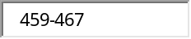
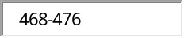
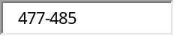
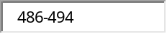
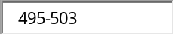 | 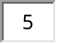
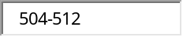
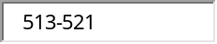
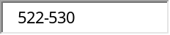
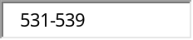
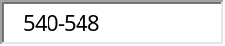

4.
The following data represents the age of 30 lottery winners.

23 | 27 | 29 | 35 | 36 | 37
38 | 40 | 46 | 49 | 49 | 50
50 | 51 | 52 | 54 | 61 | 63
65 | 67 | 68 | 69 | 69 | 73
75 | 76 | 76 | 77 | 78 | 84
Complete the frequency distribution for the data.
Age | Frequency
20-29 | 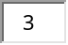
30-39 | 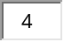
40-49
50-59 | 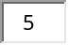
60-69 | 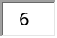
70-79
80-89 | 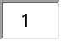

5.
Data was collected for a sample of organic snacks. The amount of sugar (in mg) in each snack is summarized in the histogram below.
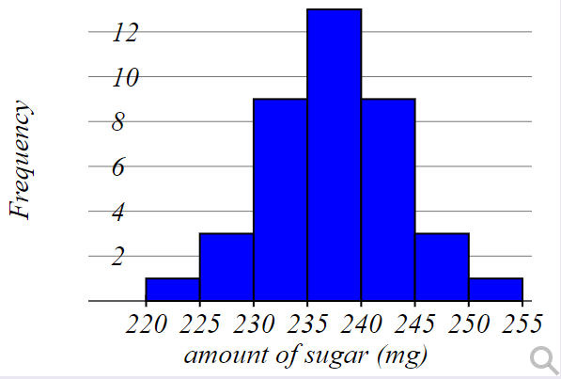

What is the sample size for this data set?
n= 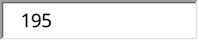

Calculate ¯xx¯ (x-bar) for the data shown, to two decimal places
x
21.1
10.5
21.7
19
10.2
22.6
12.7
12.1
20.6
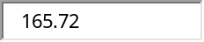

6.
A manufacturer knows that their items have a normally distributed length, with a mean of 8.4 inches, and standard deviation of 0.8 inches.
If one item is chosen at random, what is the probability that it is less than 10.8 inches long? Answers=0.6179

7.
A manufacturer knows that their items have a normally distributed lifespan, with a mean of 12.8 years, and standard deviation of 1.2 years.
If you randomly purchase one item, what is the probability it will last longer than 14 years?
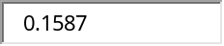

8.
A particular fruit's weights are normally distributed, with a mean of 634 grams and a standard deviation of 15 grams.
If you pick one fruit at random, what is the probability that it will weigh between 654 grams and 681 grams
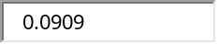

9.
A manufacturer knows that their items have a normally distributed lifespan, with a mean of 7.2 years, and standard deviation of 0.5 years.
The 10% of items with the shortest lifespan will last less than how many years?
Give your answer to one decimal place.
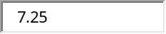

10.
The mean daily production of a herd of cows is assumed to be normally distributed with a mean of 30 liters, and standard deviation of 4.5 liters.
A) What is the probability that daily production is between 36.1 and 40.4 liters? Do not round until you get your your final answer.
Answer=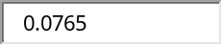 (Round your answer to 4 decimal places.)
Warning: Do not use the Z Normal Tables...they may not be accurate enough since WAMAP may look for more accuracy than comes from the table.

11.
The mean daily production of a herd of cows is assumed to be normally distributed with a mean of 30 liters, and standard deviation of 4.5 liters.
A) What is the probability that daily production is between 36.1 and 40.4 liters? Do not round until you get your your final answer.
Answer= (Round your answer to 4 decimal places.)
Warning: Do not use the Z Normal Tables...they may not be accurate enough since WAMAP may look for more accuracy than comes from the table.

